SCOE Re-Opening with the Three Rs Facilitator: Katie Brackenridge
May 6, 2021 kbrackenridge@tfcusa.org

Routines: Practice Makes Peace
(Please download your own copy)
OBJECTIVES
Educators will ...
- Understand the importance of routines in building a context for all students to thrive
- Explore routine building tools
- Think together about how to strengthen routines in order to support students’ return to in-person learning

AGENDA
Welcome & Opening
The Science Grounding
Routines to Create Supportive Environments
Routines Planner
Planning Time
Closing

Link to Resources Folder

Opening
Autopilot:
What are some of the daily activities you do on autopilot?

The Power of Routine on the Brain
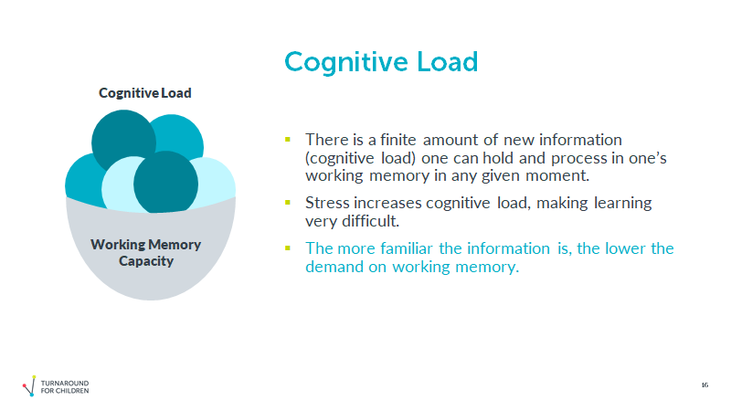

Link to How to Practice Effectively

Discussion questions:
- What new things did you learn about practice?
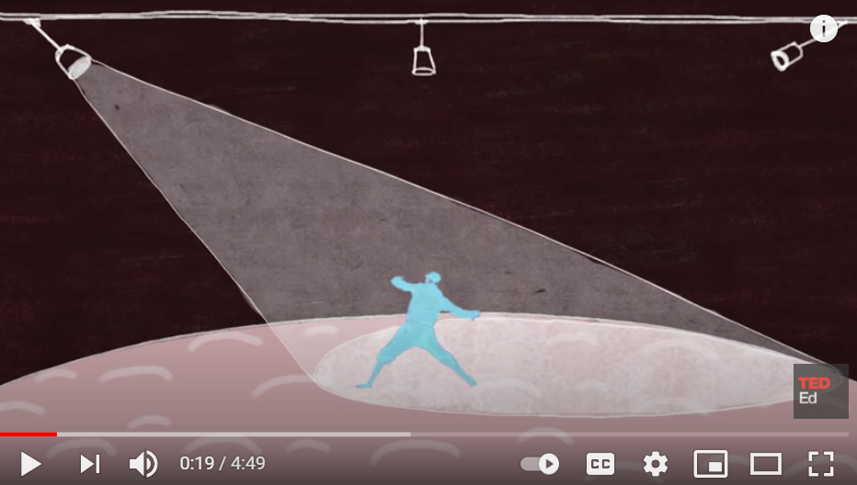
- When in your life have you engaged in effective practice?
- How do you use practice, or see practice being used, in your classrooms?

Routines to Create Supportive Environments
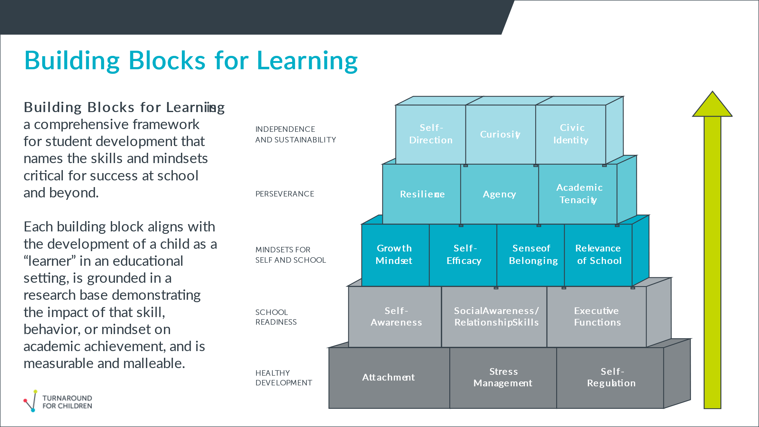
Restorative Conversations
- Read the Non-Example/Example below
Non-Example
Marcus: (shouts out answer without raising hand) It’s 22! Duh!
Teacher: Marcus, that’s a warning. We don’t interrupt.
Marcus: (eye roll)
Teacher: What is 2 x 8, Jessica?
Marcus: It’s 8!
Teacher: Marcus, that’s your second warning. I’m moving your clip. The next time is a phone call home.
Marcus: I’m just answering the question. Jeez. Everybody in this class is so slow.
Teacher: That’s it. Move your clip again and head to the hall. No recess and a phone call home.

Example of Restorative Conversation
Marcus: (shouts out answer without raising hand) It’s 22!
Teacher: (moves closer to Marcus) Marcus, I’m glad you’re excited to show what you know, but let’s give everyone a chance. … What is 2 x 8, Jessica?
Marcus: It’s 8!
Teacher: (to class) Let’s take a minute to share our answers with a partner. Turn to your shoulder partner and discuss your answer. Make sure that you can prove your answer in two different ways. We’ll come back together in one minute. (quietly) Marcus, you seem to be having trouble respecting our community rules. If you need to, you’re welcome to take a break in our cool-down area, or you can continue to participate if you can do so without interrupting others. It might help to write down your answers on a whiteboard and you can check them off or correct them, even if you don’t get to share with the whole class. Either way, you and I can chat about how to fix this problem after class. I know you can do it.
Marcus: (chooses to write his answers and sits quietly for the rest of the fast fact review)
After class …
Teacher: Marcus, I want to talk about what happened in class today. One of our class rules is to respect the speaker. You struggled with this today. Why do you think we have that rule?
Marcus: So that everyone gets a chance to speak and feel heard.
Teacher: That’s right. Also, when we’re practicing math, it’s important that I can tell who understands and who needs more help. When you interrupt, I don’t know who needs more practice. Now that you’ve had a minute to think about it, how did your actions affect our class today?
Marcus: I kept us from practicing, and I didn’t show respect to Jessica.
Teacher: Right, and what would happen if you interrupted practice every day.
Marcus: We wouldn’t get better at math. Teacher: That could be. How do you think you can make this right?
Marcus: I can apologize to Jessica before class tomorrow. Also, I will raise my hand before I answer.
Teacher: Great – if your hand is raised, I’ll know you are excited to show what you know. I won’t be able to call on you every time, but I’ll make sure you get at least one chance in class. Also, I think it’s a great idea to apologize to Jessica. Why don’t you write your apology today during lunch, and I’ll read it and help you with any needed revisions. Make sure to include what you did wrong and your plan for doing better in the future. Feel free to use the sample apology in the back of the room to help you get started.

- Reflect on these questions:

- What is the end result of the non example interaction? What is the end result of the example interaction? Which result is most likely to yield a transferrable or long term solution?
- The non example is a more efficient approach. What is lost with this efficiency?
- What structures and/or systems does the example teacher have in place to make her approach possible?

- Discuss with your colleagues

Link to Toolkit on Restorative Conversations

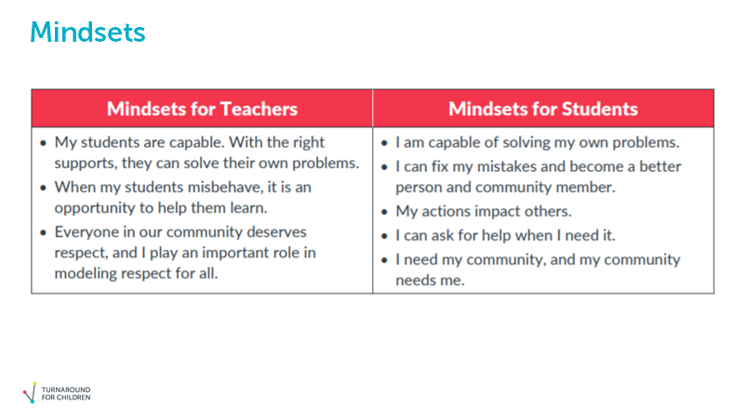

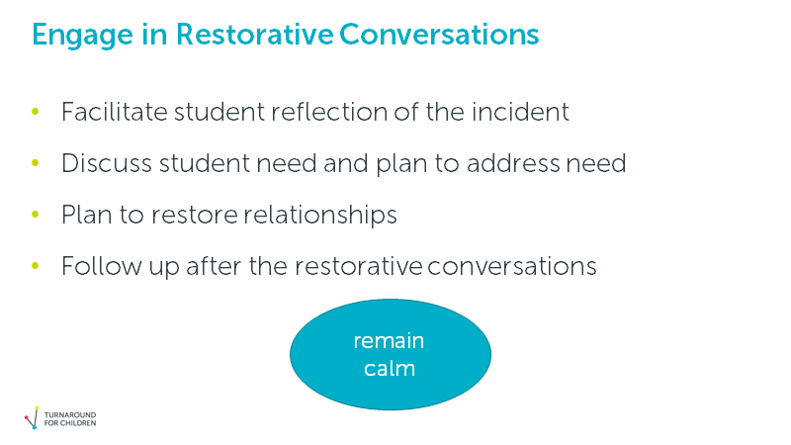

Scenario
It was time for the class to transition from math to music class, but Sandy didn’t want to go to music. When the teacher called her table to line up, Sandy stayed seated. After multiple reminders, Sandy finally rolled her eyes, stood up, and slowly walked to the line. The teacher reminded Sandy that the class needed to be on time to music, but Sandy continued to move slowly. Once to the line, she pushed Keyana out of the way so that she could stand by her friend and not be at the end of the line. The class arrived late to music. When the music teacher asked why, Sandy shouted out, “Because this class is boring!”

Discussion questions:
- What would be the traditional approach to this situation?
- What might happen in a restorative approach? Consider the conversation and the follow up.
- What needs to happen at the school and district level for this to be possible?

Routines Planner
Quick Write – Everything you know about building a routine with students:

Consider the Procedures below:
- Which ones are on your list?

- Which might you add?

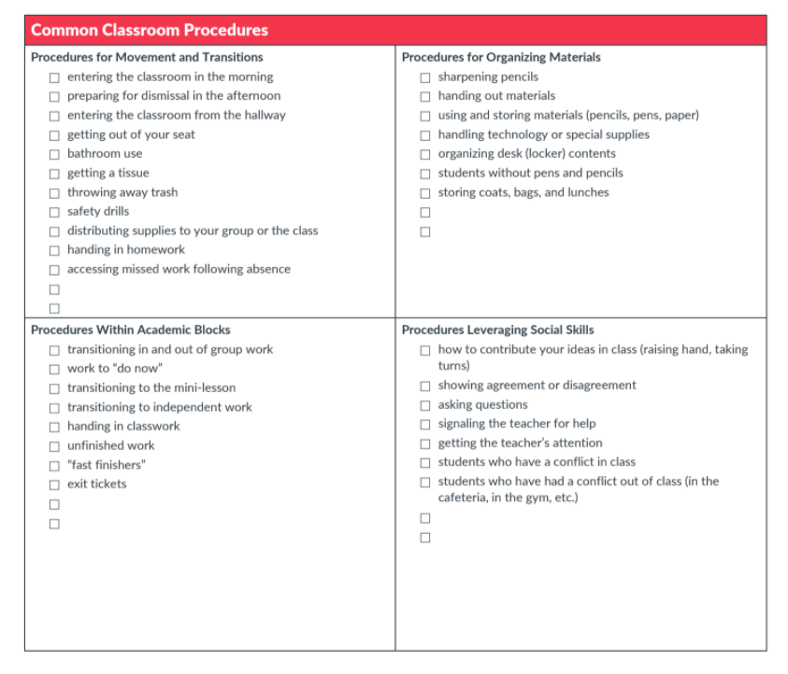
Link to Common Classroom Procedures

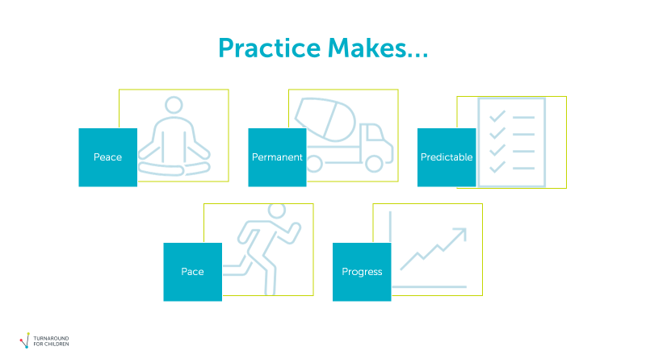

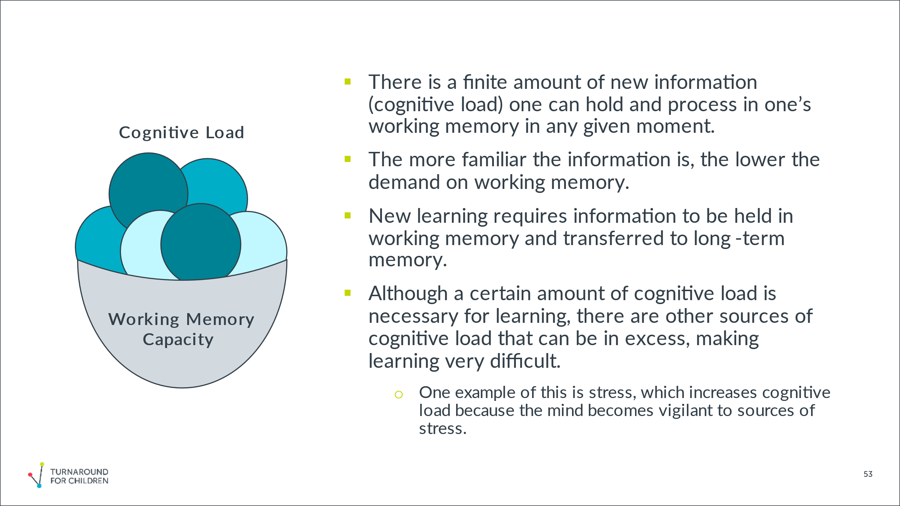

Link to Routines Planner
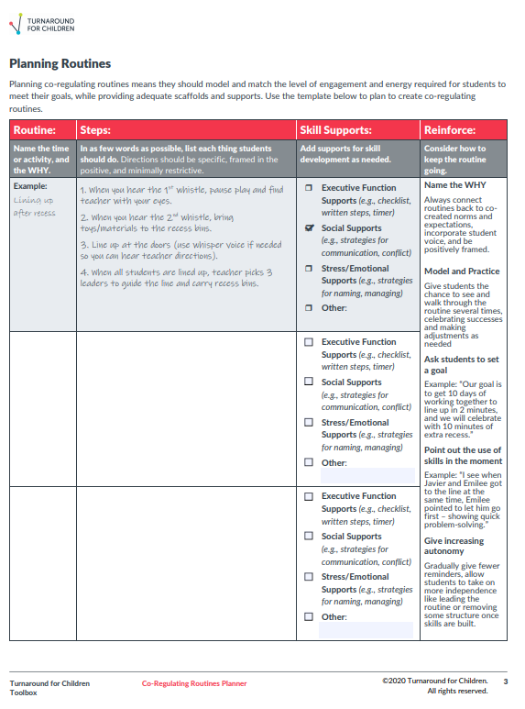

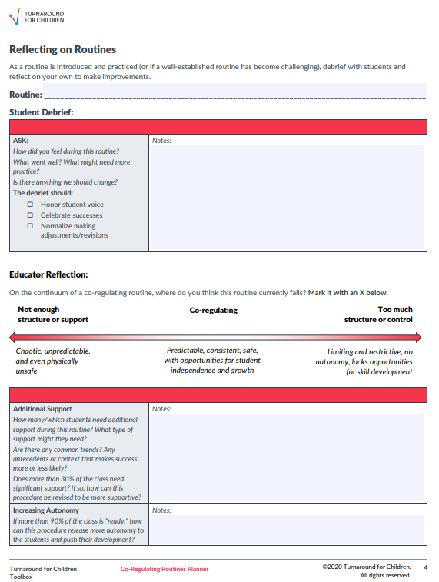

Planning Time
Role-Alike Discussion:
What catches your attention from this information?
What are the implications for your role?
How might these ideas and practices show up in your plans for next year?

Closing
Please complete the Exit Ticket: https://bit.ly/TFCExit_SY21_Training

Find more resources at https://turnaroundusa.org

