Resilience
Don’t Rock the Boat

OBJECTIVES
Educators will . . .
- Understand the relationship between emotions and learning
- Explore the power of co-regulating emotions to build resiliency in students, and in the process, tune up emotional self-awareness
- Consider how to effectively implement resiliency-building tools and strategies in your schools or district

AGENDA
Welcome & Opening
Rowing in Tandem
- Integrated social, emotional and cognitive learning
Going Over
- Responding to emotions and stress
Checking the Weather
- Well-Being Index
Ready to Put In

Link to Participant Materials Folder
Opening
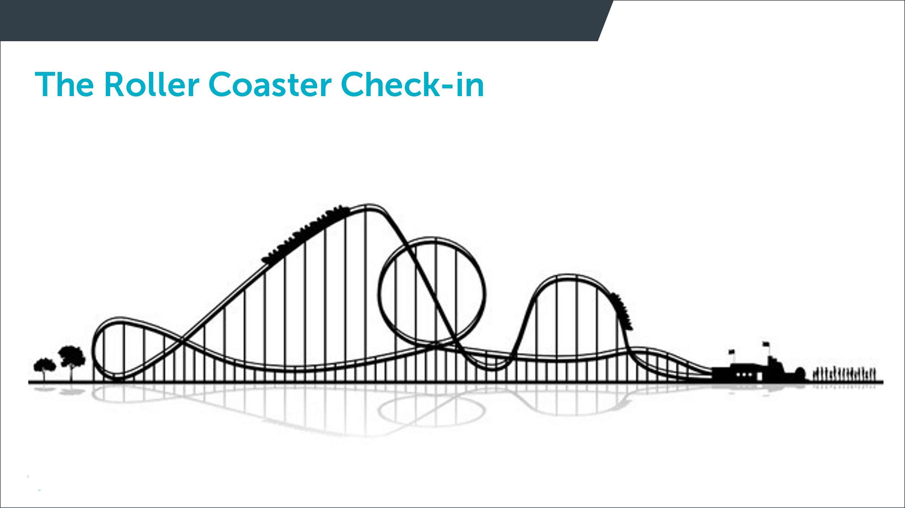

Whole Group Discussion:
- What might be some trends in the way we’re feeling as a group?
- What might we need to manage as a group this afternoon based on some of those trends in our feeling?
- How might you use a check-in like this with students or staff?

Rowing in Tandem
Integrated social, emotional and cognitive learning

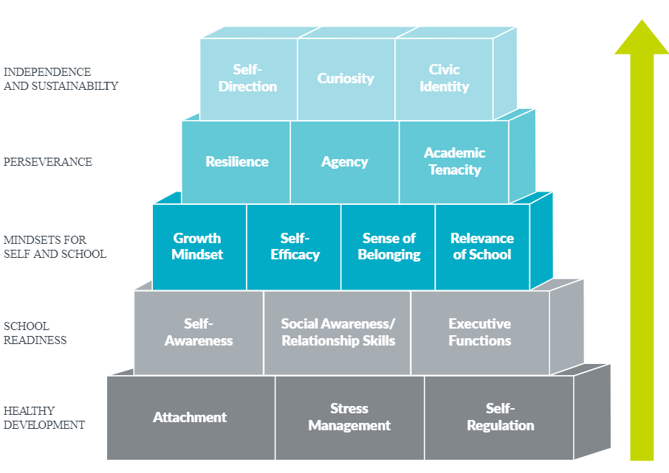
Knowledge Forum, Washington, DC
February 1, 2016
Immordino-Yang Video Link

Small Group Discussion:
- What sparks your interest?
- How does this information run counter to traditional educational practices and structures?
- What are the implications for you, your school or your district?

Going Over
Responding to Emotions + Stress

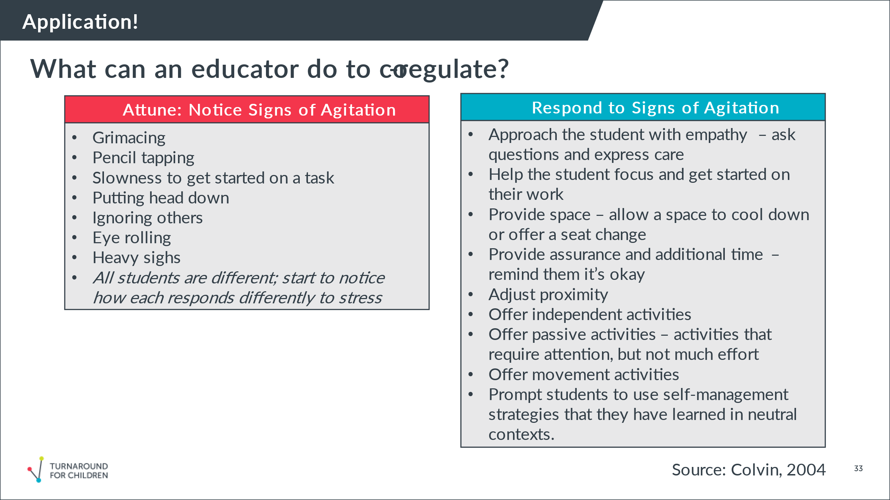

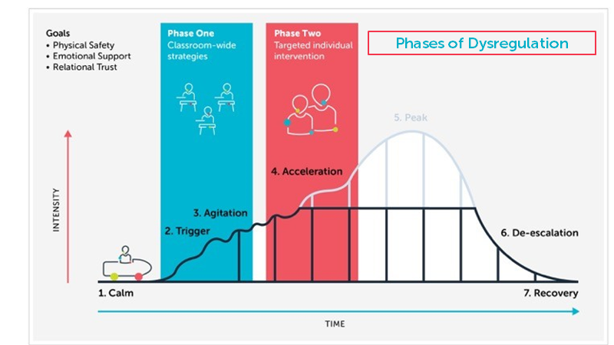

Behavior Chain
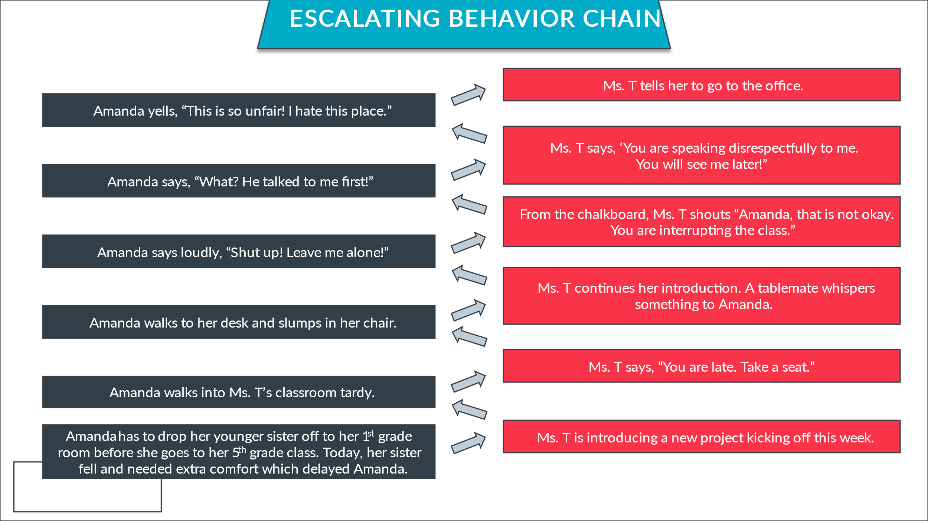
Reflect:

What pushed this teacher’s buttons?

What pushed this student’s buttons?

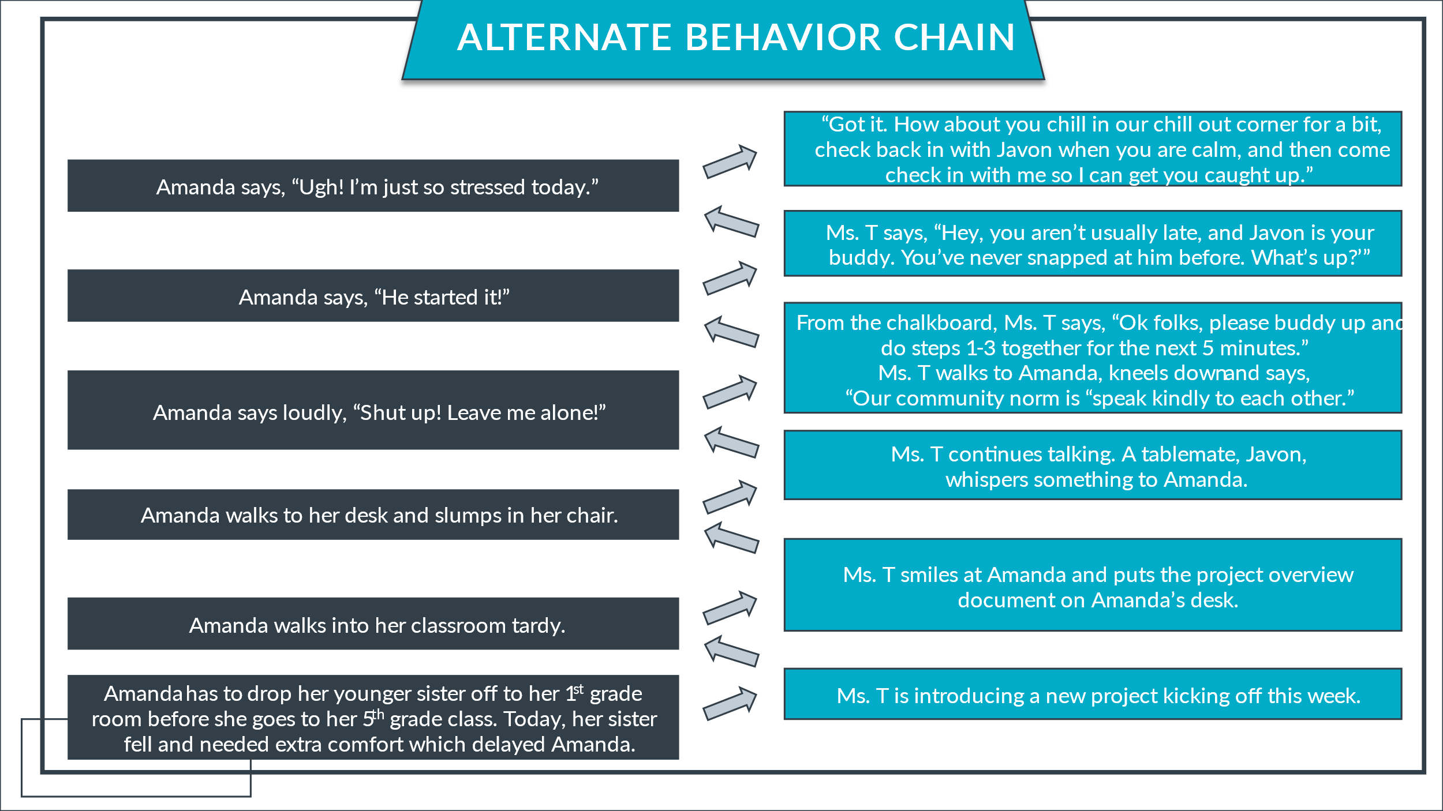
Reflect:

What is one important difference between this pathway and the last?

What is another way that the teacher could have de-escalated the situation?

TOOL: Reflecting on My Triggers and Responses
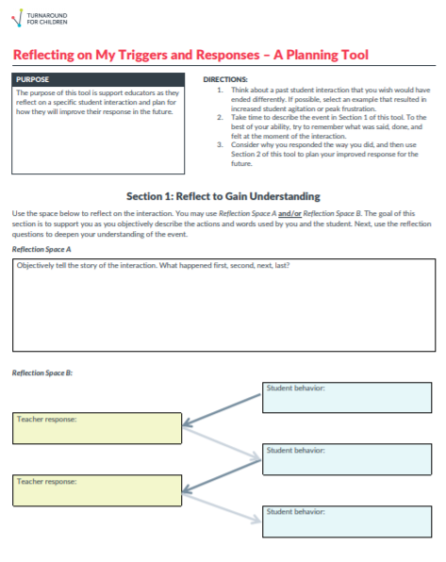

TOOL (CONT): Reflecting on My Triggers and Responses
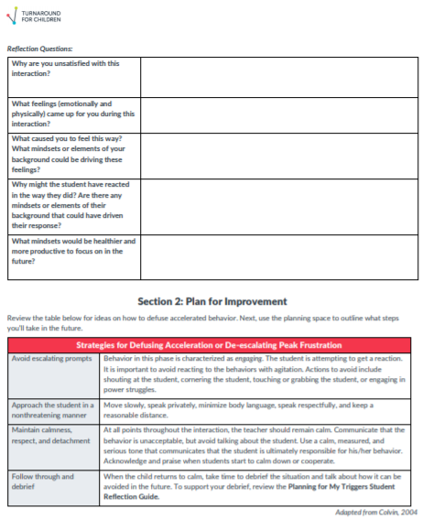
TOOL (CONT): Reflecting on My Triggers and Responses
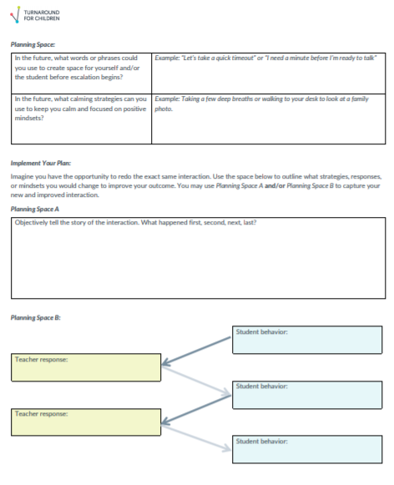

TOOL: My Emotional Response Strategies List
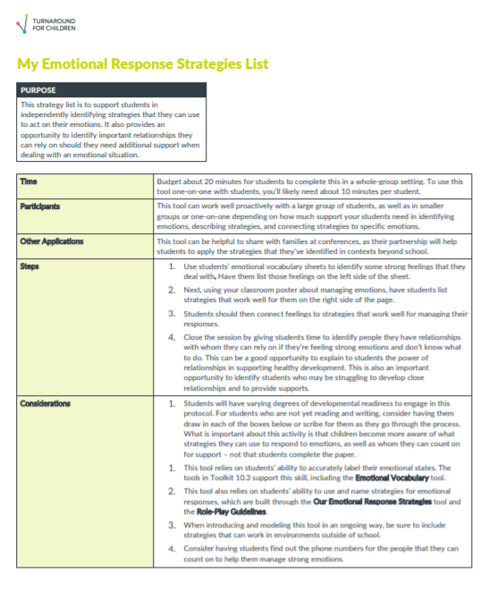

TOOL (CONT.): My Emotional Response Strategies List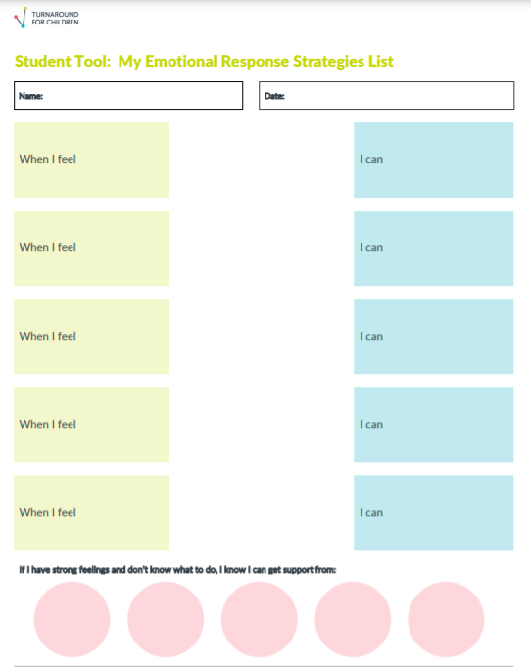
TOOL (CONT.): My Emotional Response Strategies List
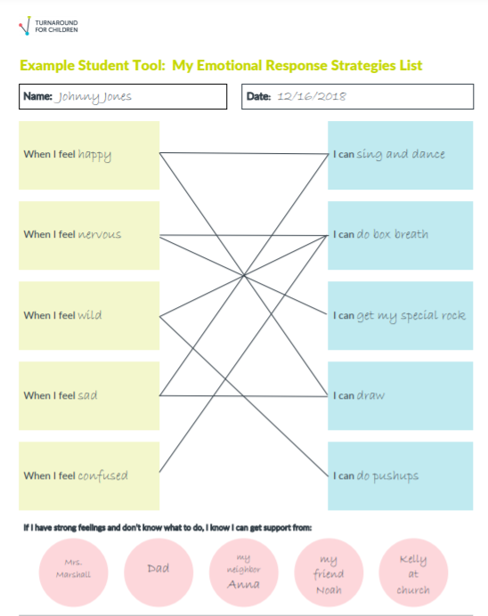
Small Group Discussion:
  - What is one of your triggers?
  - How do you react when you are triggered by that?
  - How might you proactively prepare yourself to respond instead?
  - How might these tools help you and your students?

Checking the Weather
Well-Being Index
Link to the Well-Being Index

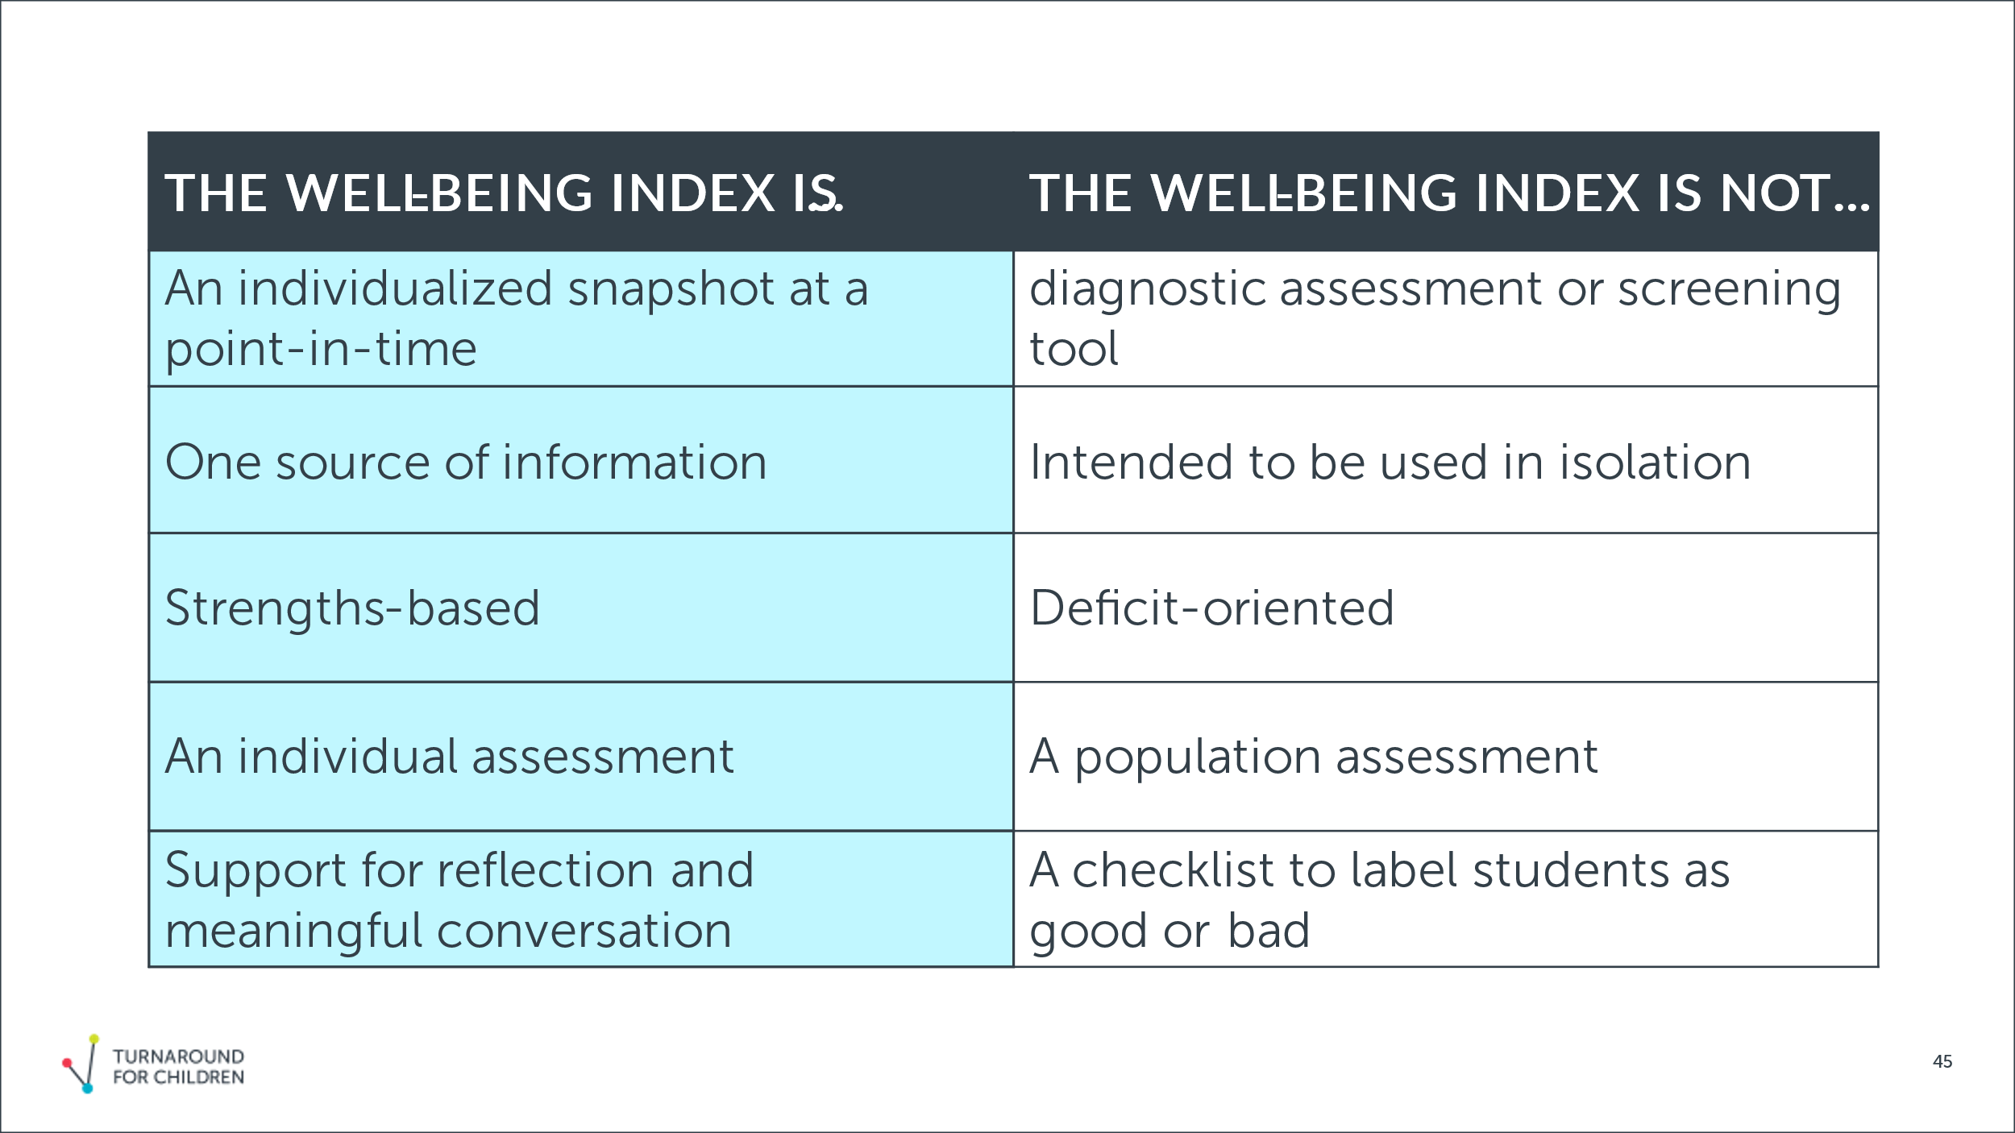

Elementary Index
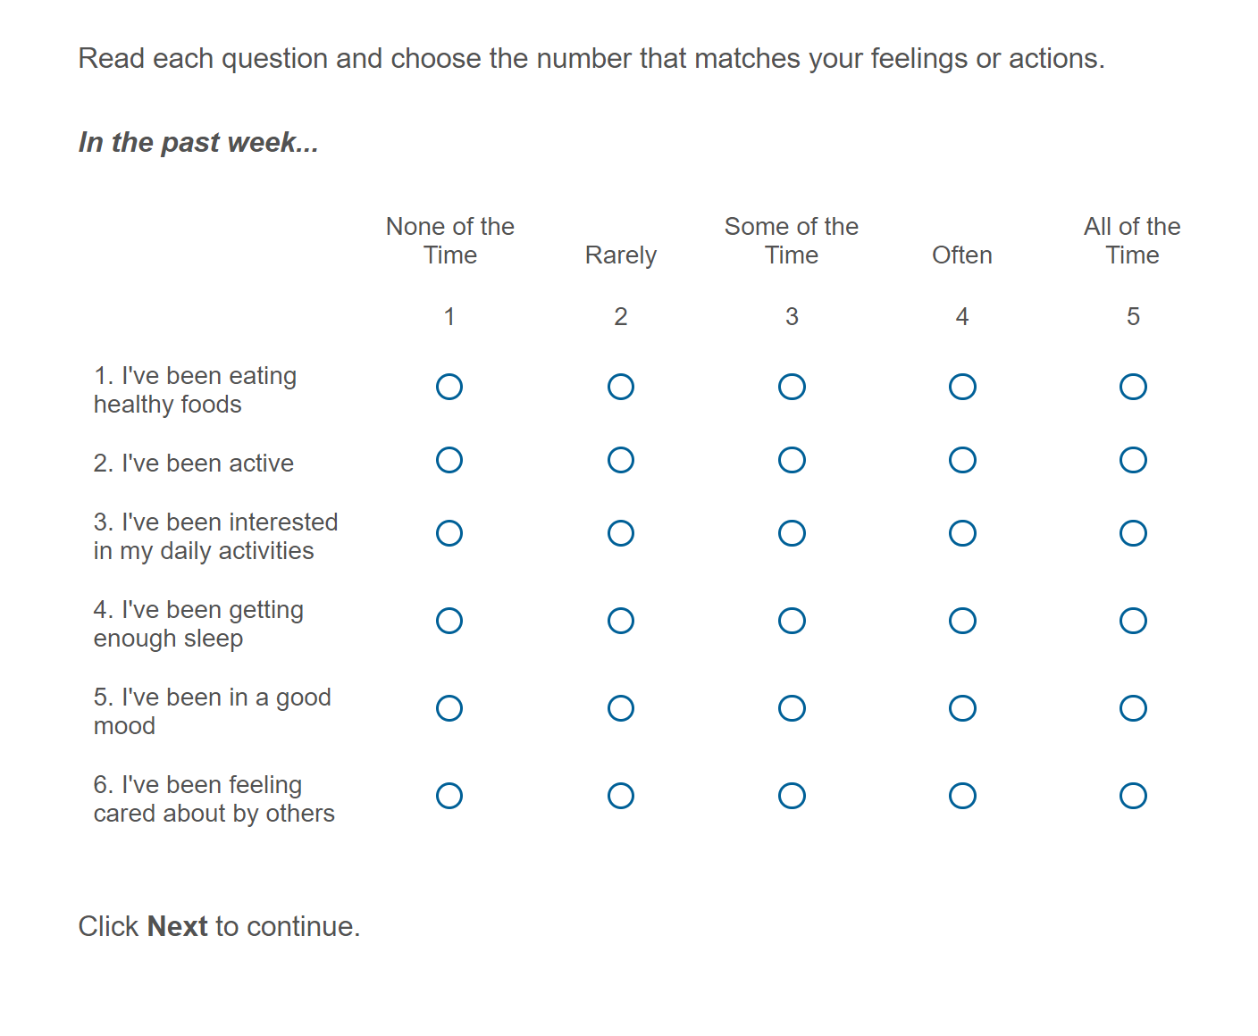

Secondary Index
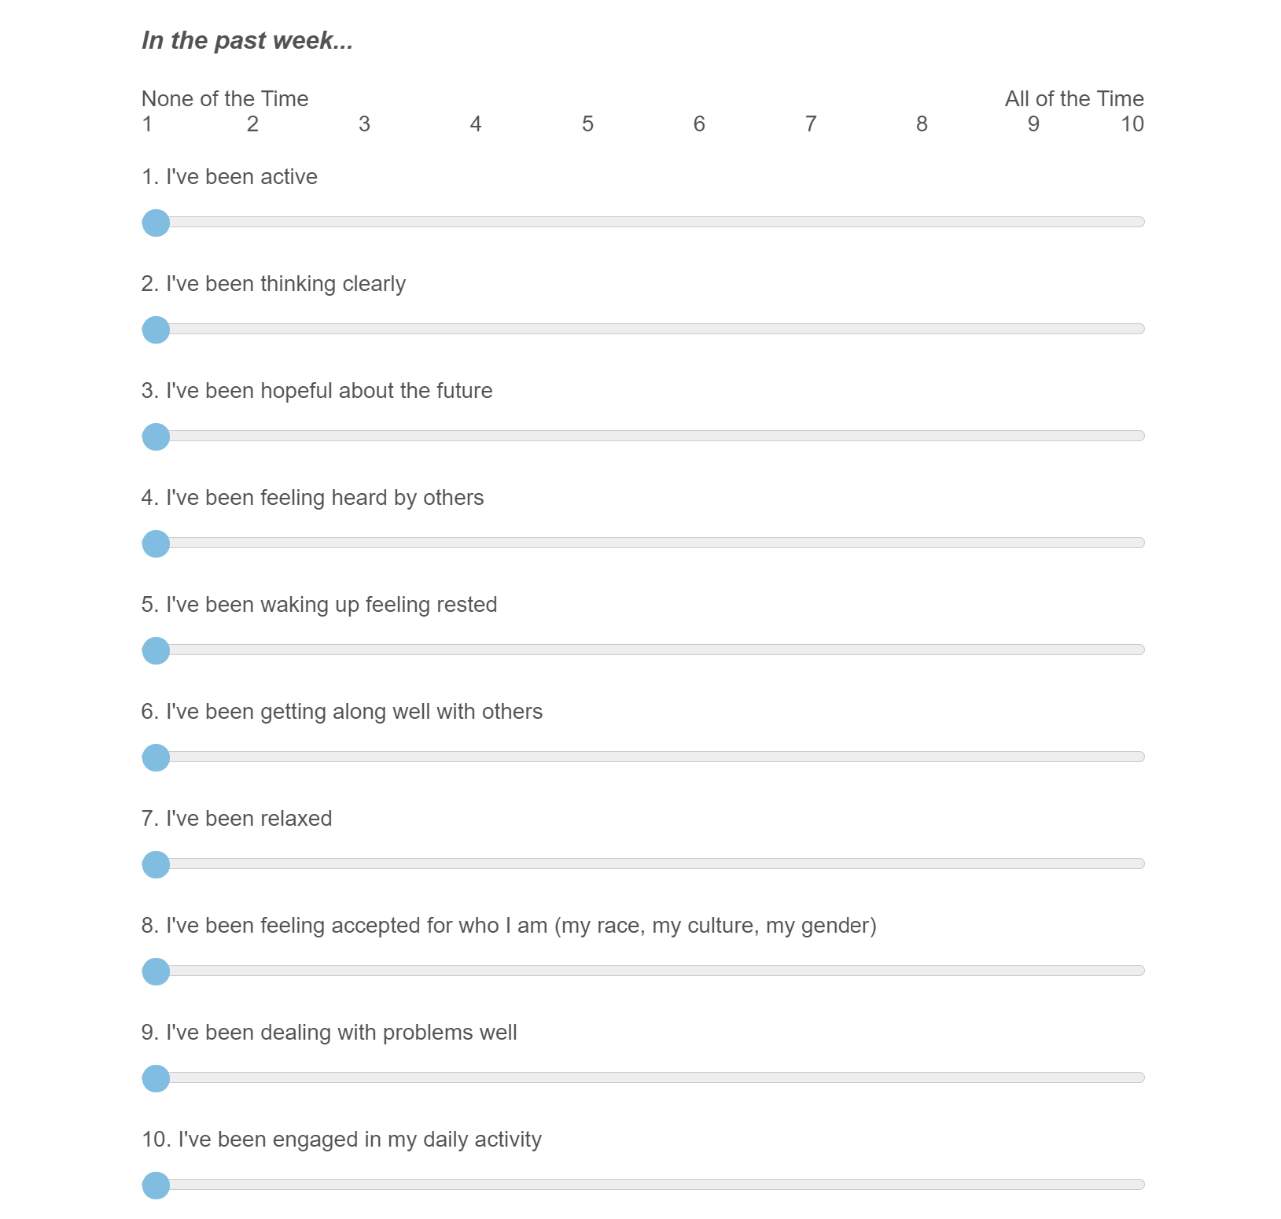
Role Alike Discussions:
- How can this tool support students’ resilience?
- How might you use it in your role?
- What questions do you have?

Ready to Put in
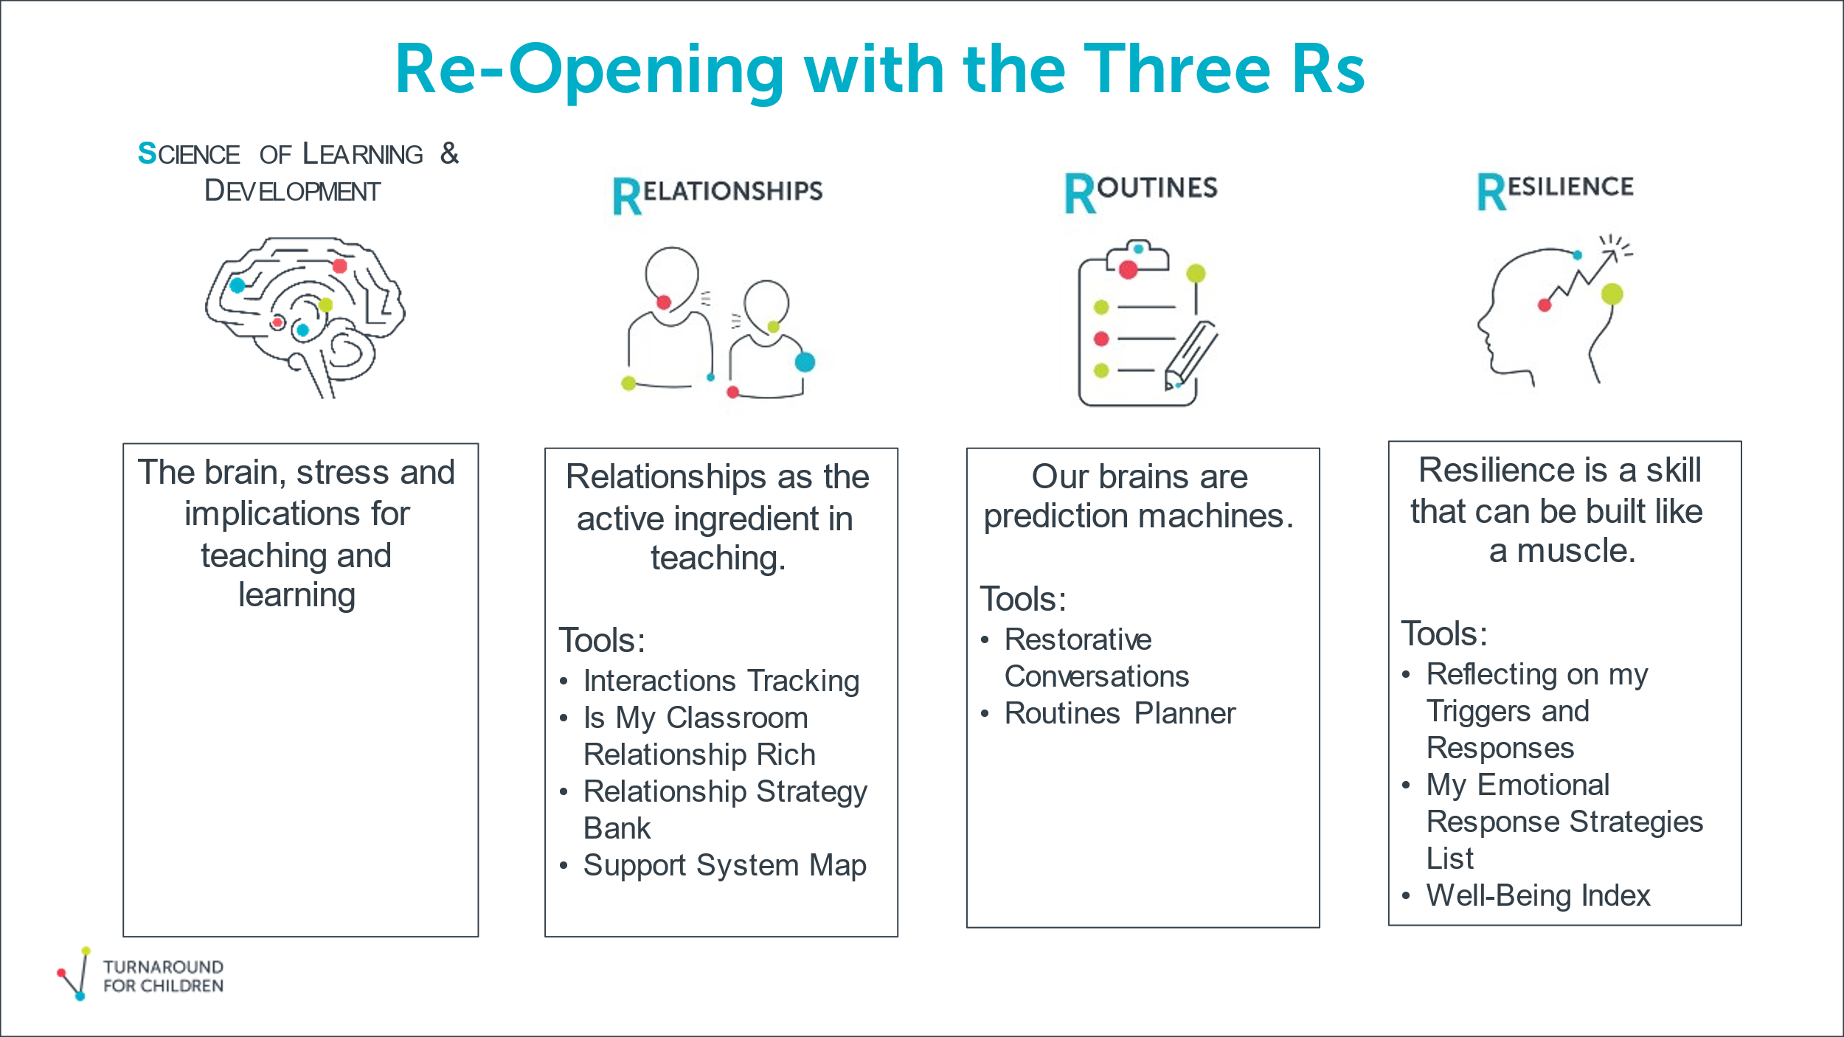

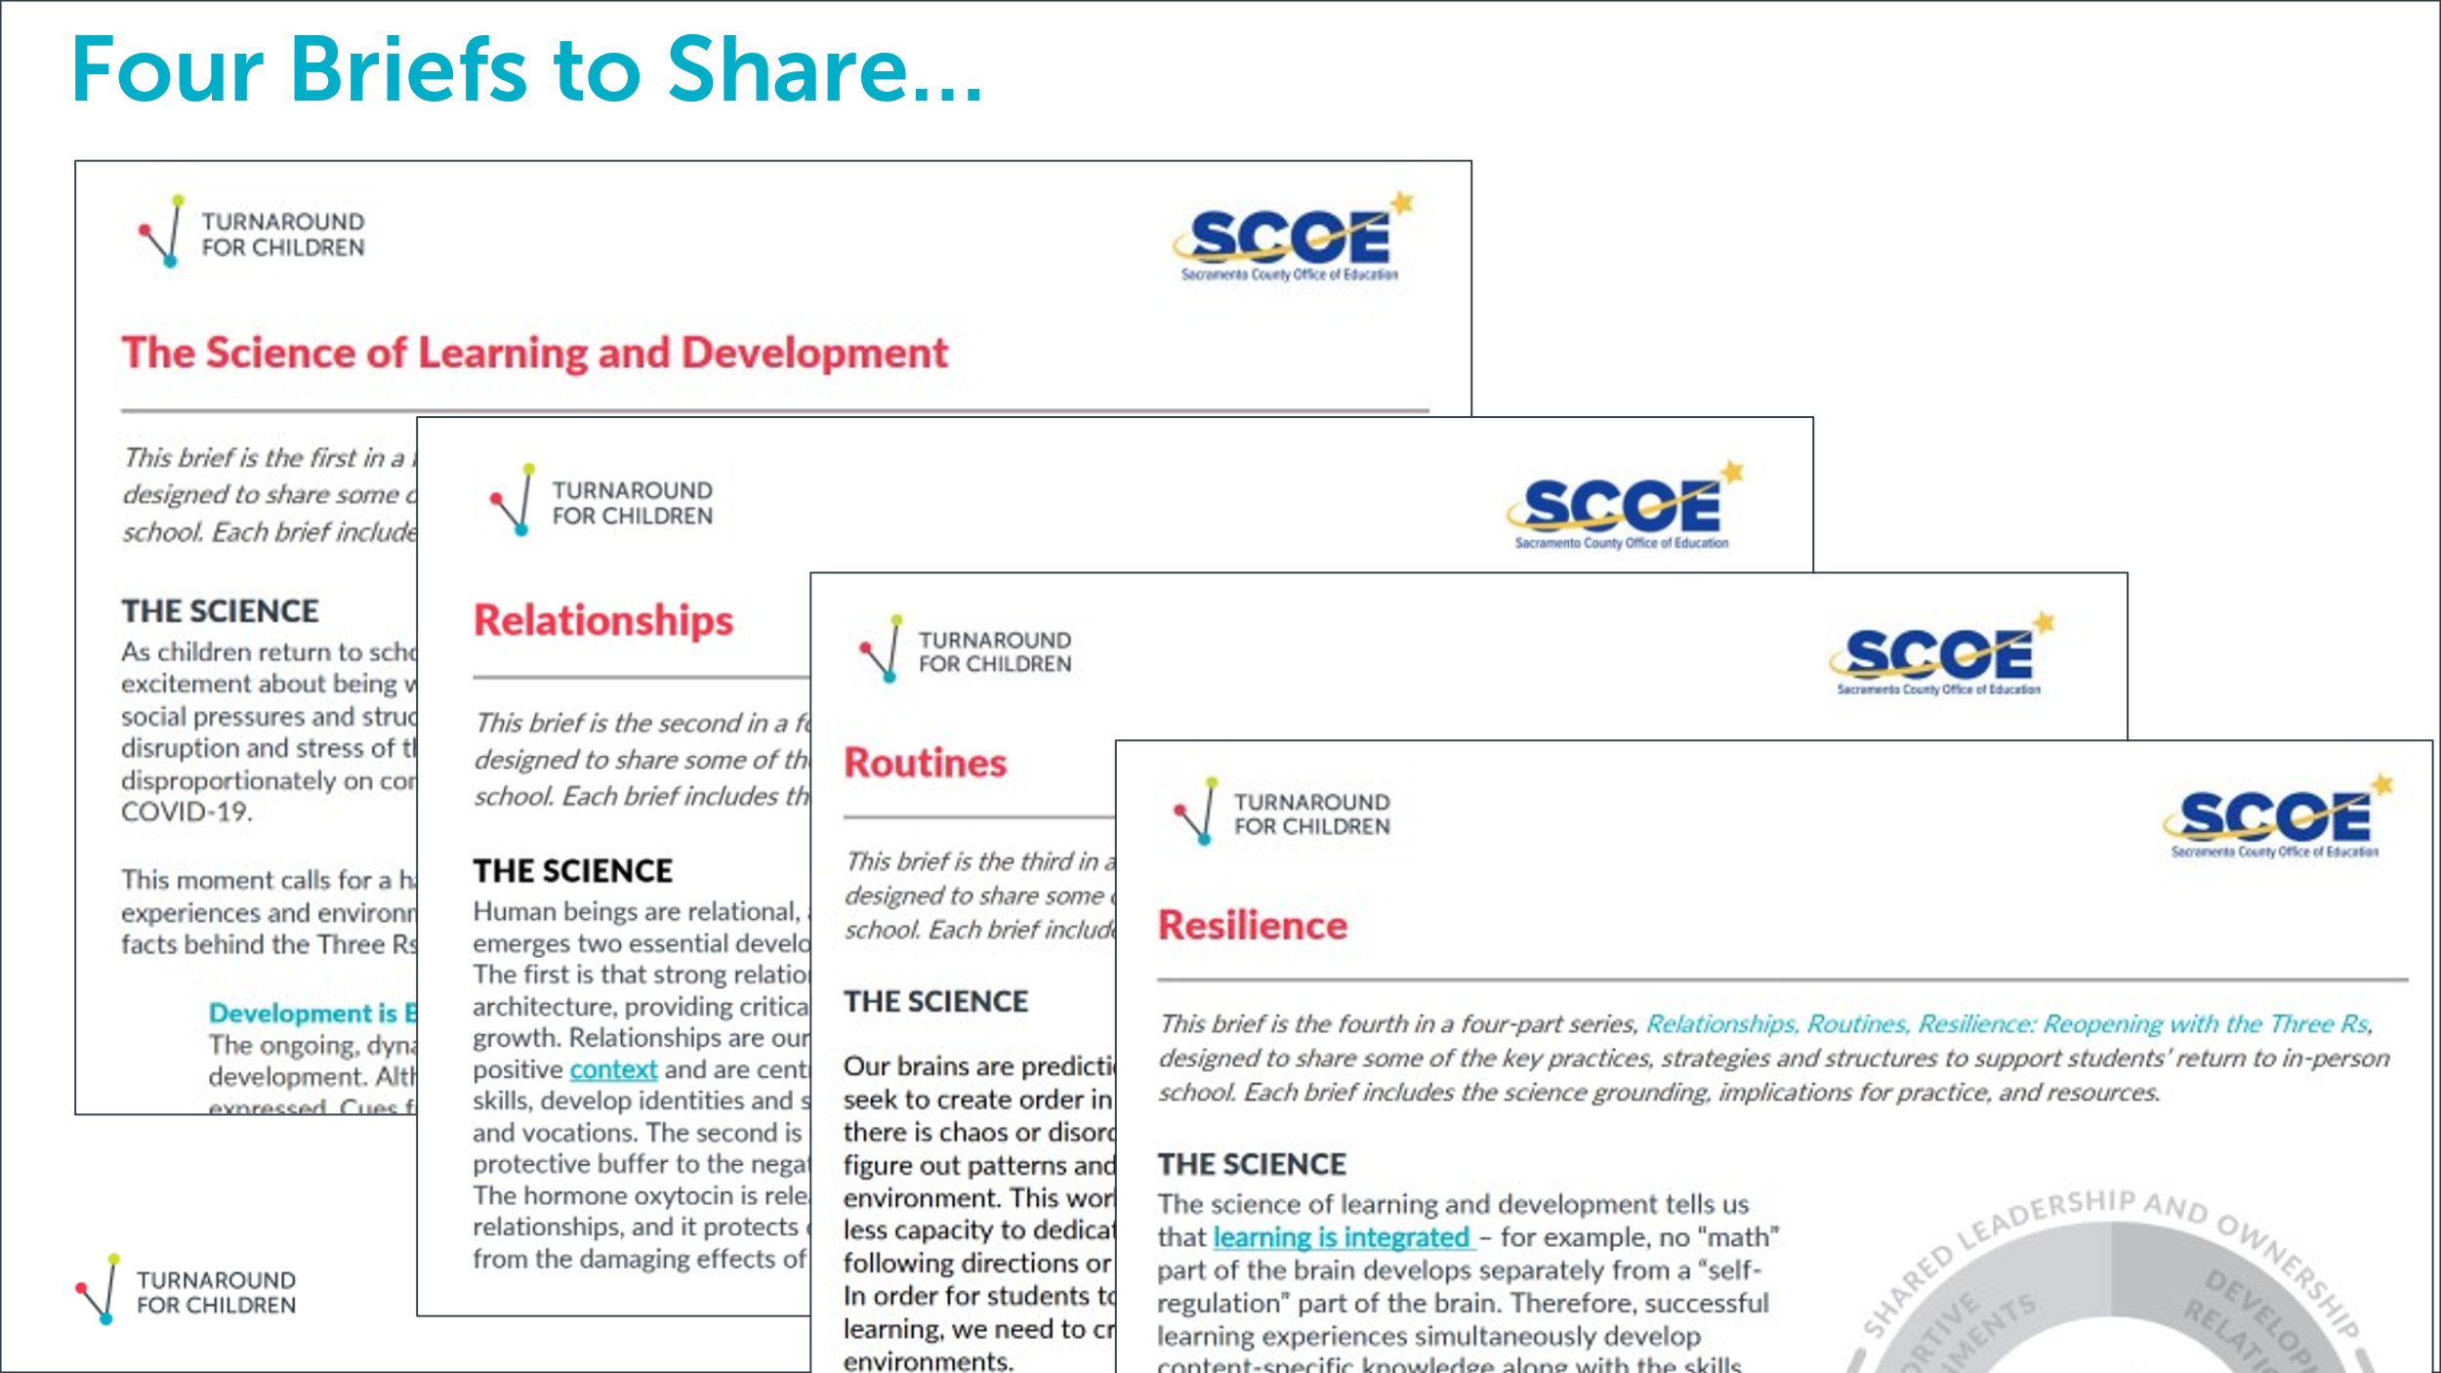

Thank you for completing the Exit Ticket - https://bit.ly/TFCExit_SY21_Training
Additional Resources:
- Toolbox
- Well-Being Index
- Crisis Action Pack

