SCOE Re-Opening with the Three Rs Facilitators: Katie Brackenridge
Session 2: Relationships kbrackenridge@tfcusa.org

Relationships: Beyond Being Nice
(Please make a copy)
OBJECTIVES
Educators will be able to…
- Define positive developmental relationships and explain the impact of relationships across development.
- Review several relationship-building tools and strategies.
- Apply today’s learning to their work in schools and districts.

AGENDA
Welcome & Opening
Whole Child Design – Developmental Relationships
Relationship-Building Tools
- Well-Being Index
- Is My Classroom Relationship Rich?
- Interactions Tracking Tool
- Relationship Strategy Bank
Link to Resources Folder
Planning Time
Closing

Opening: What Does Impact Look Like?
Small Group Discussion
In a group of 4, document the behaviors you encountered that created the positive or negative experiences you remember.

Positive Behaviors | Negative Behaviors
Specifically, what did the teacher do or say that created the positive interaction.  If I were looking in the window of the classroom, what would I have seen him/her doing? | Specifically, what did the teacher do or say that contributed to the negative experience?  What did it look like?

Whole Child Design: Developmental Relationships

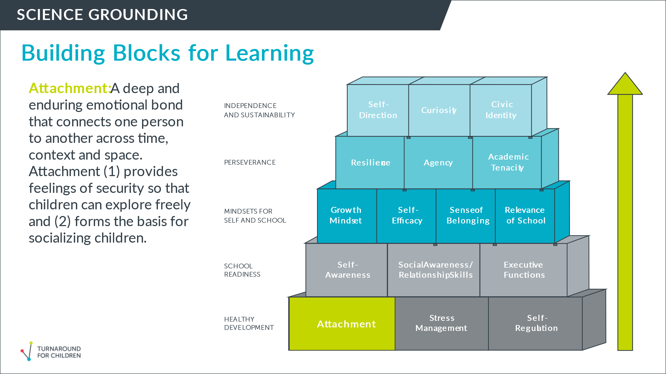
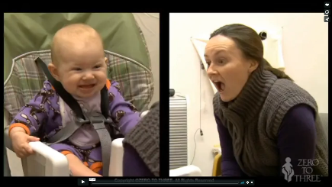
Chat Box Prompt:
What strategies or practices do you use as an educator that demonstrate “serve and return” or co-regulation?

Link to Still Face Experiment

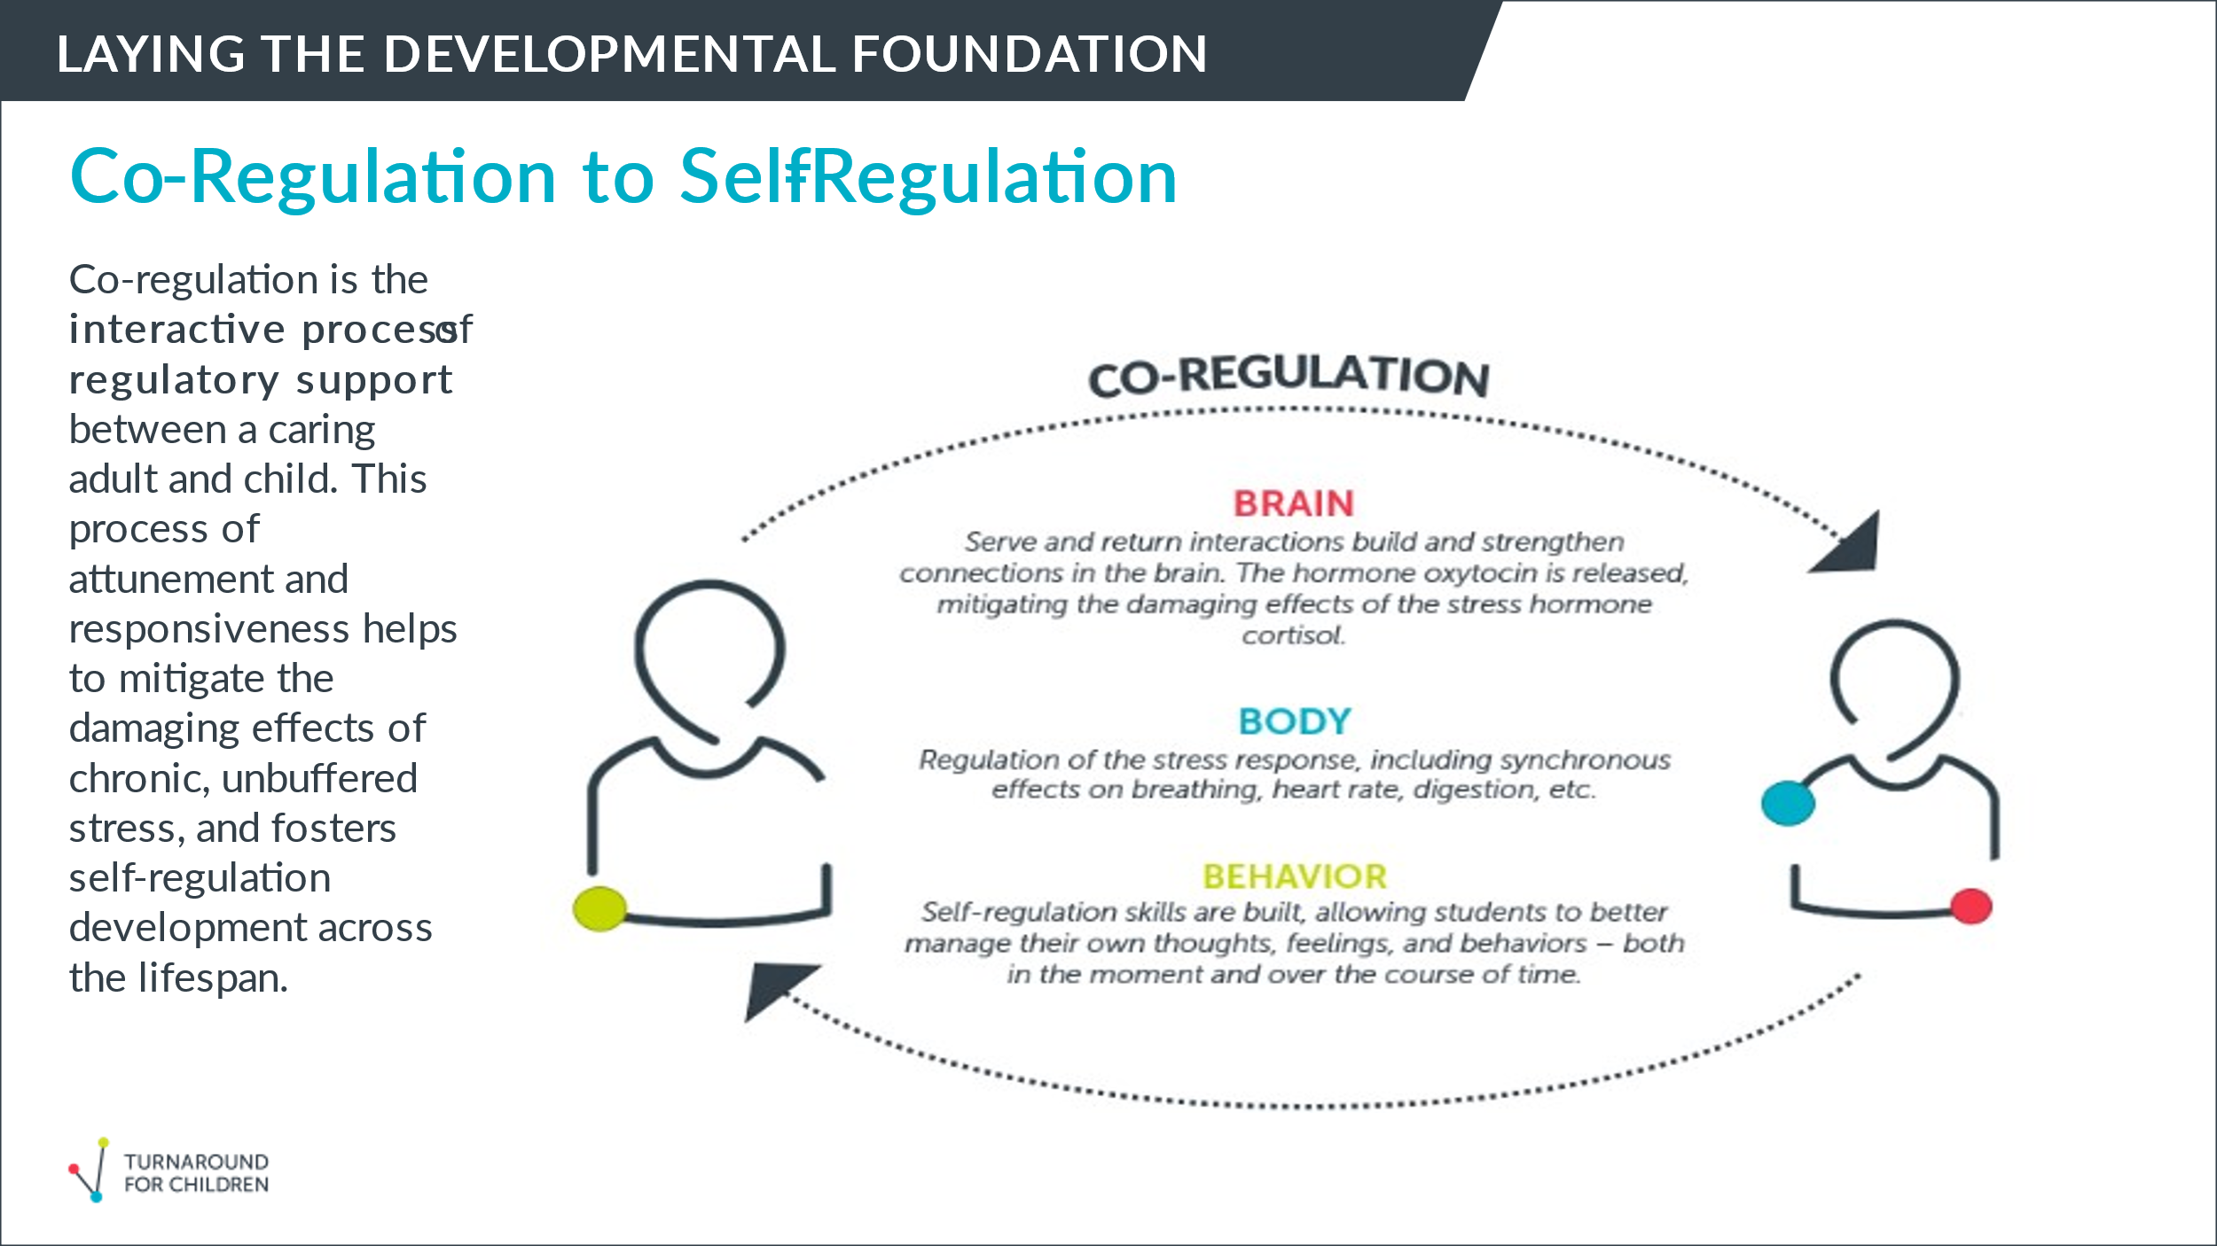
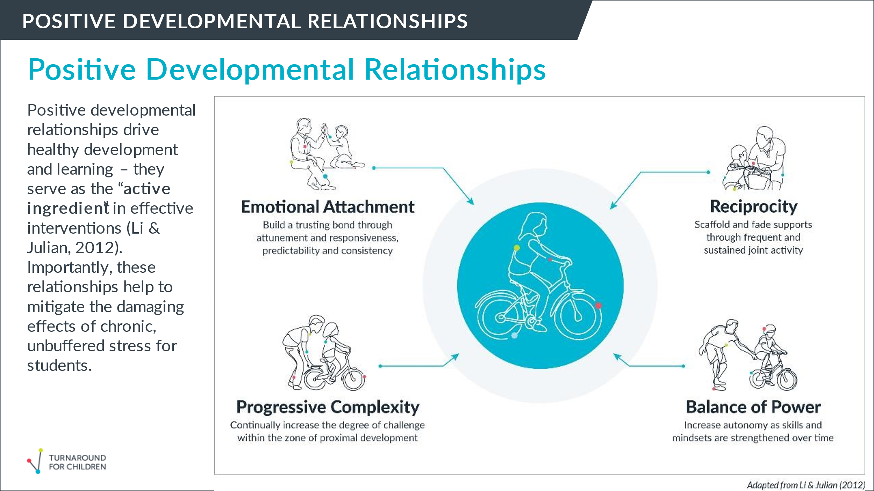

Individual Reflection
Thinking back to the T-Chart in the opening activity –
Can you see the four components of positive developmental relationships at work in that relationship? Which ones?

Small Group Discussion:
- What is resonating with you about this content?
- How does it reflect your values as an educator?
- Where do you have questions or wonderings?

Relationship Building Tools
All tools can be found in the Resource Folder (except the Well-Being Index)
Well-Being Index

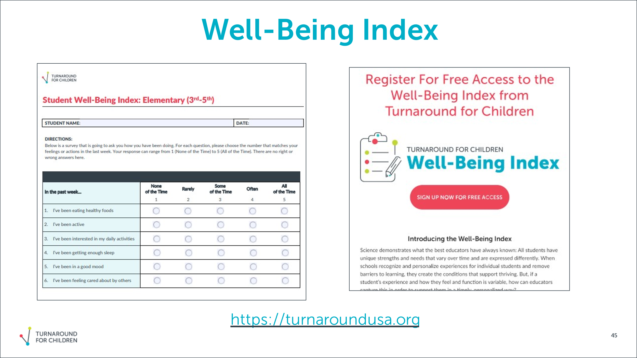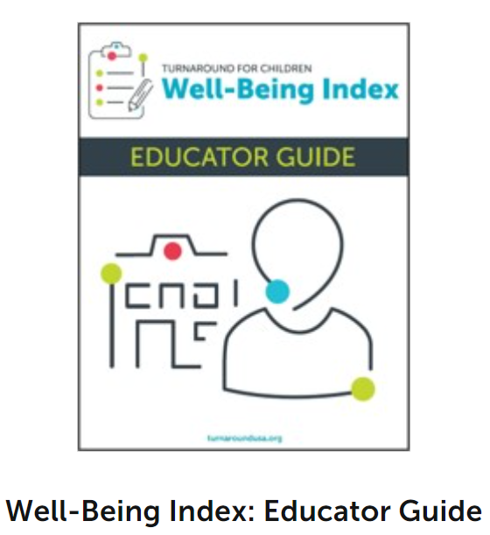

Is My Classroom Relationship Rich? (Teacher)

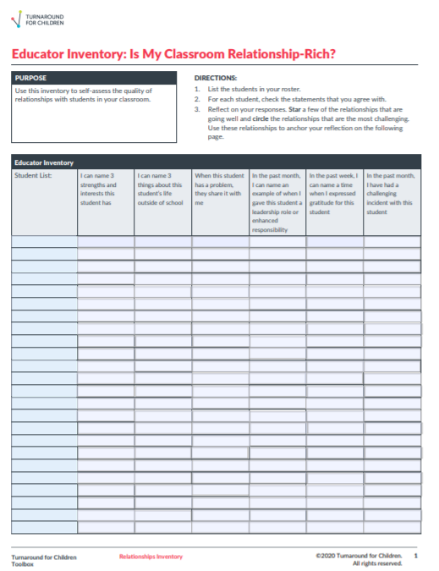

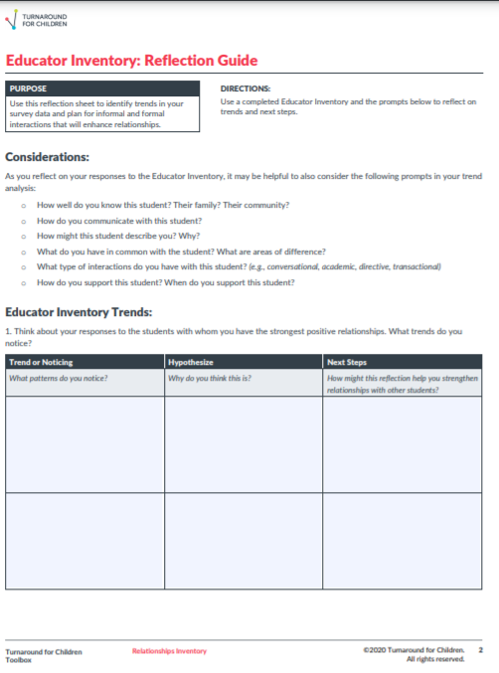
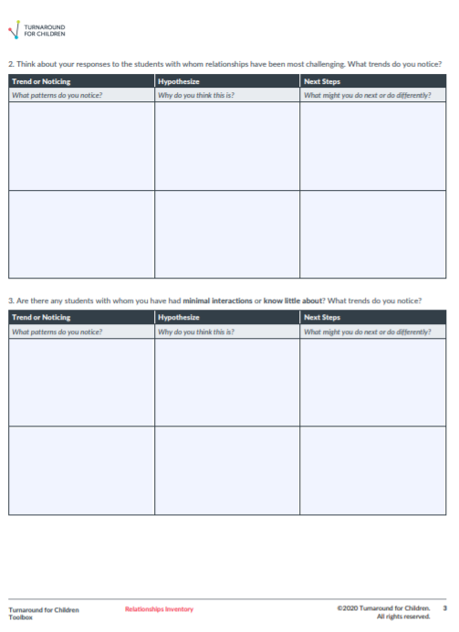

Is My Classroom Relationship Rich? (Student)

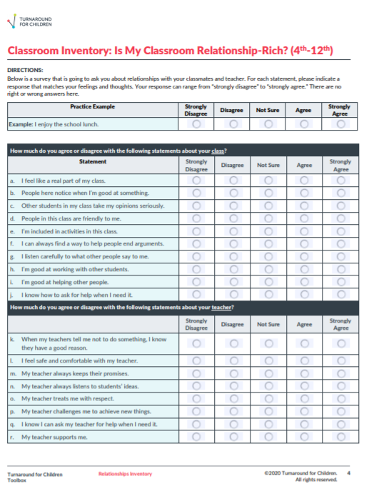
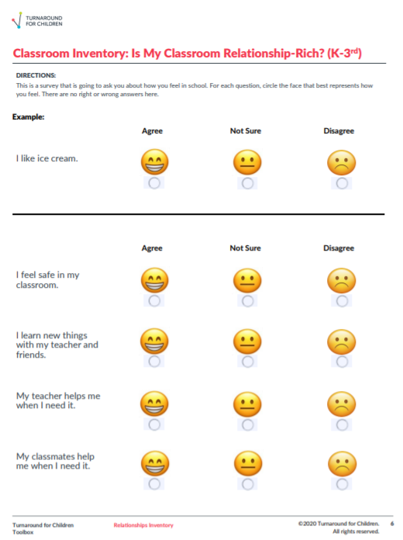

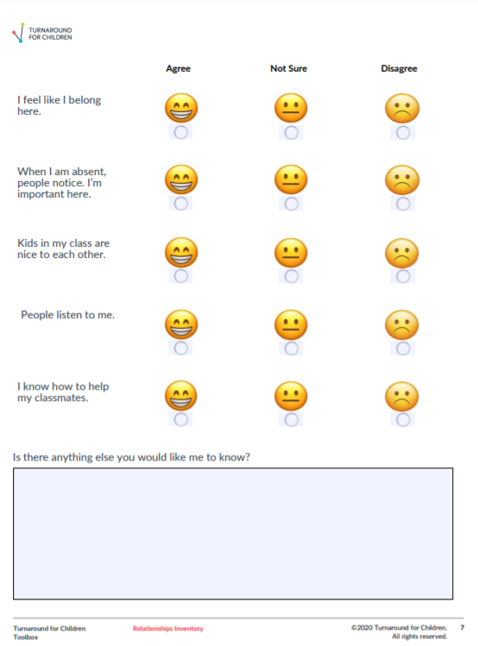

Processing Information from “Is My Classroom Relationship Rich”

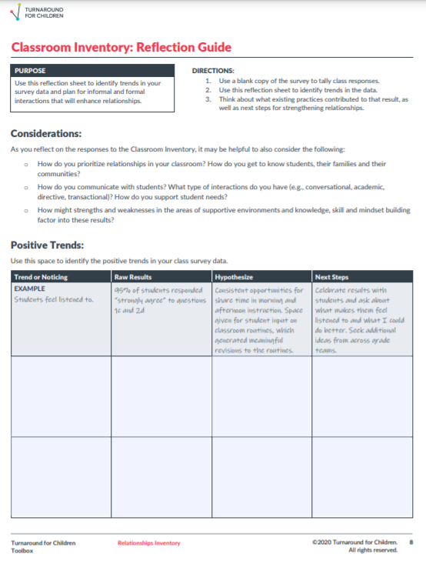

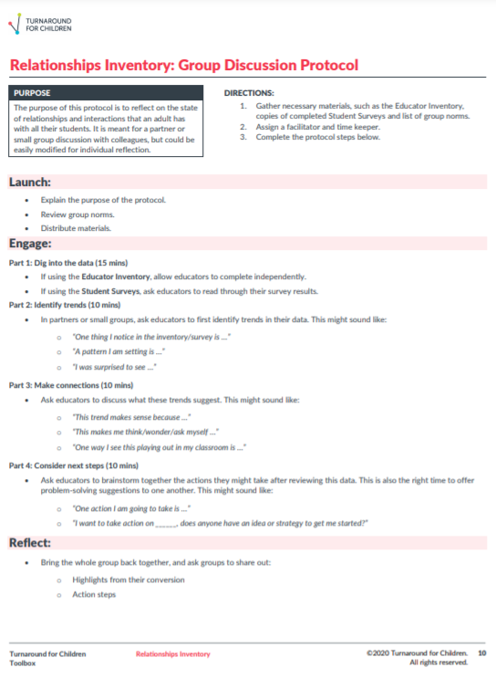

Interactions Tracking Sheet

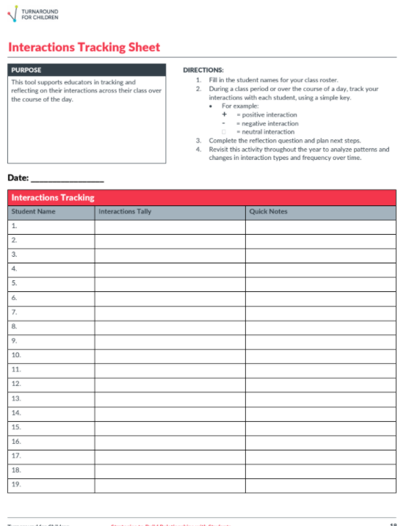
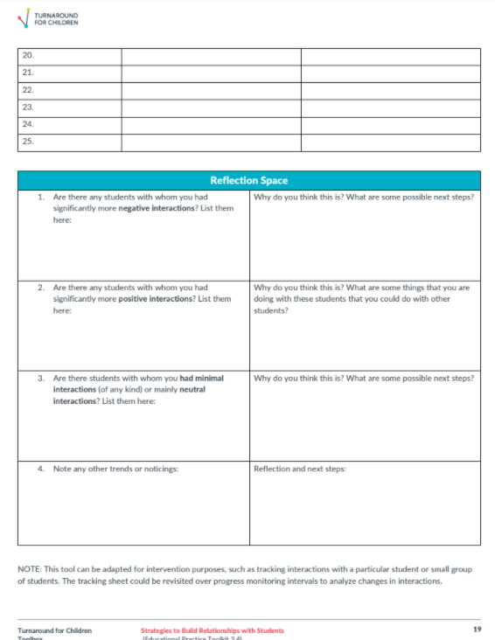

Relationship Strategies Bank

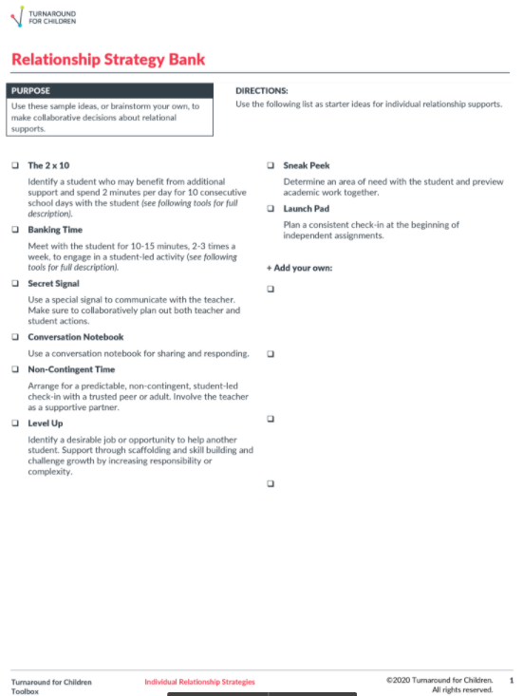

Banking Time Strategy – within the Relationship Strategies Bank

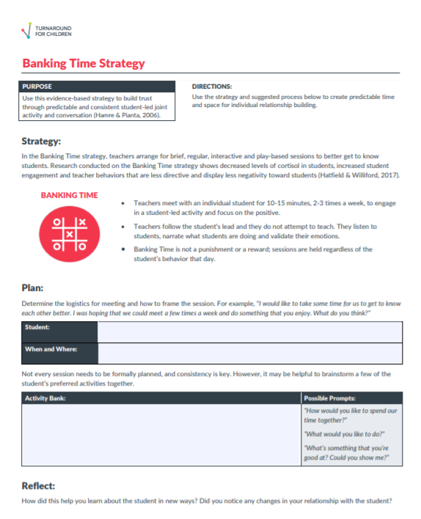

Planning Time

Small Group Discussion:

Take 5 minutes to individually look at the tools.
- What tools do you find interesting? Which are familiar?
- What is challenging about relationship-building? How might these tools or information help?
- As a leader in your school or district, what can you specifically do to promote relationships?
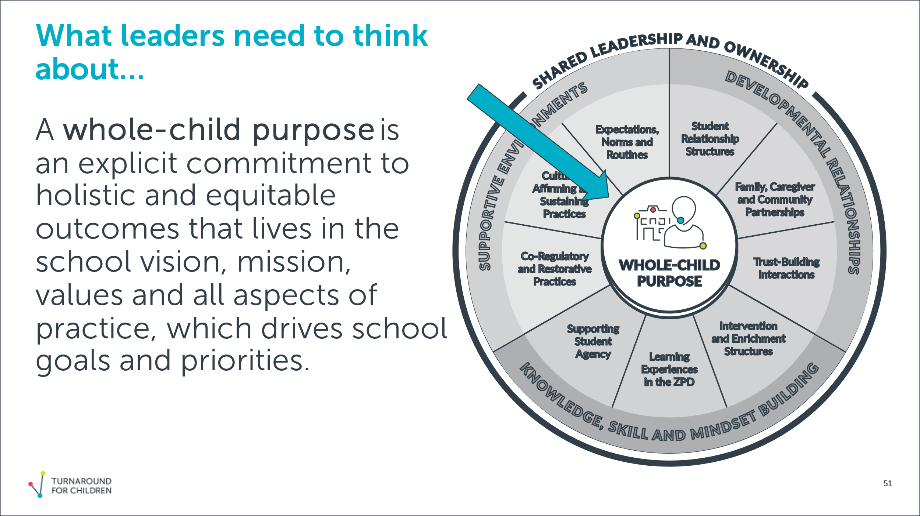
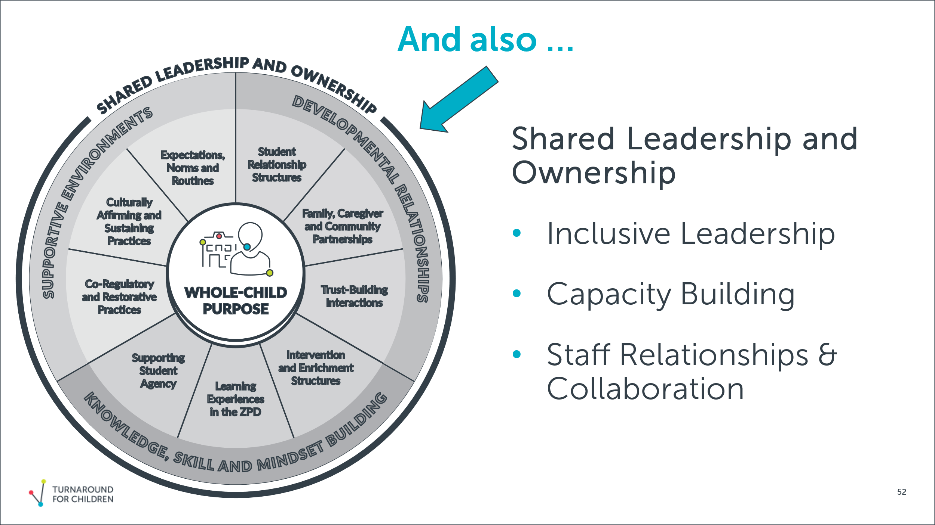
Closing
Call to Action:
- Plan to build intentional relationship-building strategies into your re-opening plans.
- Share these tools and information with others.
Please complete the EXIT TICKET - https://bit.ly/TFCExit_SY21_Training

