A Family Guide to Understanding California’s New Testing System:
California Assessment of Student Performance and Progress
Part 2

This spring students in grades 3-8, and 11 will take online tests in English-language arts and mathematics using a computer. These tests are known as the Smarter Balanced Assessments and they are part of California’s new testing system called the California Assessment of Student Performance and Progress or CAASPP. This is Part 2 of the Family Guide to Understanding California’s New Testing System, and it focuses on what your child will experience when he or she sits down to take these tests. Part 1 of the Family Guide provides an overview of the new testing system. It and other resources can be found on the Sacramento County Office of Education’s website at www.scoe.net/statetests.

Tests Measure Real-World Skills
As the world and workforce evolve, what and how we teach our children must also evolve so that they are prepared to live and work in an ever-changing world. Over the course of their lives, our children will have to apply what they know in new and different ways, including ways we can’t even imagine today. Critical thinking and problem solving skills are important for students as they prepare for success in college, career, and life. These skills can’t be measured by multiple choice questions alone or paper and pencil tests. This is why the new Smarter Balanced tests were developed.

Questions Look Different
The new online tests give students many different types of test questions that keep them engaged and challenged. Students who participated in last year’s field test (i.e. “test of the test”) said they liked the computer testing much better than the paper and pencil testing. Students found the questions more interesting, and as a result, they stayed more engaged with the test.

Some questions are multiple choice, but others include several steps. Some questions might ask students to drag and drop items from one part of the screen to another part in order to solve a problem (see sample question below) and some might ask students to draw a graph.

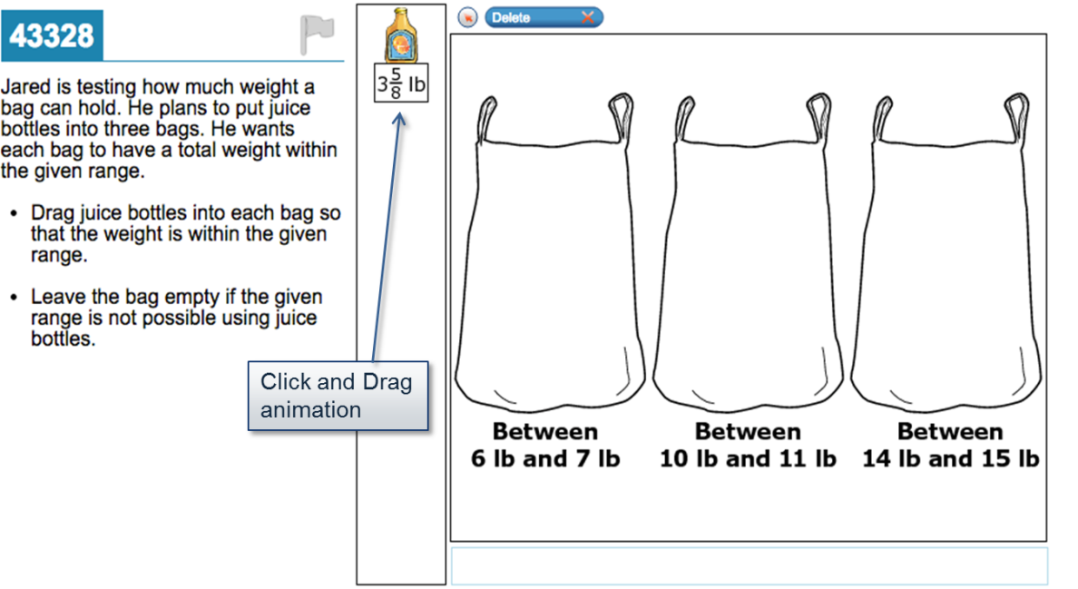

One of the most important changes is that these new questions are evaluating a students’ knowledge in context – for example, student might be asked to select a word of the same meaning to replace a word in a paragraph, rather than chose a synonym for a word standing alone. In another example, students might be asked to highlight a sentence in a passage that supports the meaning of a word rather than selecting the definition of the word from multiple options. In many cases, even in mathematics, student will be asked to type answers to questions rather than selecting from multiple options.

Each Test Has Two Separate Parts
The test for both English-language arts and mathematics is divided into two parts: (1) Computer-Adaptive Test or CAT and (2) Performance Task.

- Computer-Adaptive Tests Adjust to Each Student’s Ability
“Computer-adaptive” tests adjust the difficulty of the questions based on the answers that students give, thus providing a different testing experience for each student. As students answer questions correctly, they receive more difficult questions. Incorrect answers trigger easier questions. This will be a different testing experience for many students, and it is something parents should keep in mind as one thing they can talk to their children about before testing.

CAT also produces results that are more accurate than the old paper and pencil tests, and CAT also keeps students more engaged throughout the test. Depending on your child’s grade, he or she will receive between 40 and 45 questions in English-language arts and between 30 and 35 questions in math.

- Performance Tasks Measure Deeper Understanding
The performance task is the second part of the test and it is a collection of activities and questions related to a real-world situation that requires students to use multiple skills to show their understanding. Students are provided with articles, portions of text, videos, or diagrams, and then are asked to analyze them in order to solve a problem. To help students prepare for the performance tasks, teachers will lead students through a classroom activity before testing to help introduce students to new vocabulary and the context for the task.

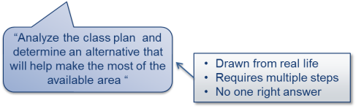
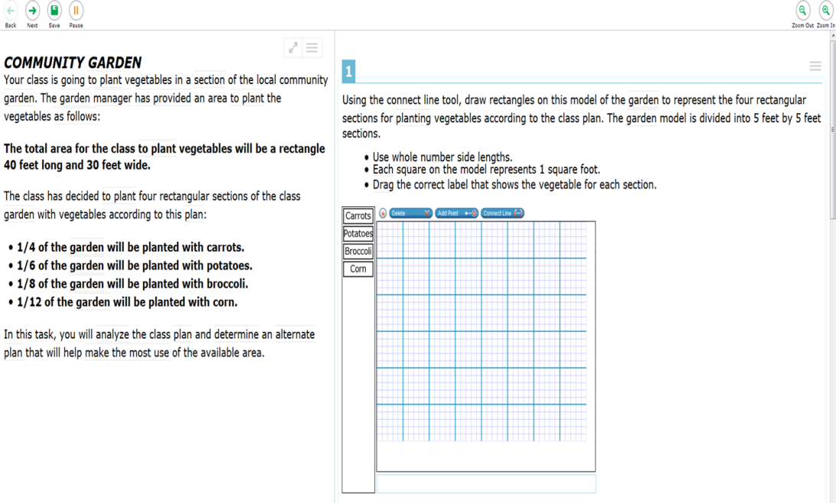
A performance task for English-language arts, for example, might ask students to read several grade-level appropriate paragraphs from different sources (e.g., newspaper article, website, or book) about the same topic. Students would then be asked questions about the different sources, such as which source would be the most helpful in learning about the topic, and what details from the source support their conclusions. To measure deeper understanding of math skills, students might be presented with a real-world problem like planting a community garden (as shown in the graphic above).

The performance task will also be done on a computer, but it isn’t computer-adaptive. This means that all students in the same grade at the same school will take the same performance task. The performance task will take between one to two class periods to complete.

Tests are Not Timed; Estimates Similar to Old Tests
The new tests are not timed. The table below shows the estimated total testing time for each subject area. The total testing time for each subject includes time for both the computer-adaptive test and the performance task. In most cases, your child will take the entire test over several days.

 | Estimated Testing Time
 | English-Language Arts | Mathematics
Grades 3-5 | 4 hours | 3 hours
Grades 6-8 | 4 hours | 3 hours, 30 minutes
Grade 11 | 4 hours, 30 minutes | 4 hours

For More Information
Your child’s teacher or principal is the best place to start if you have other questions about testing this spring.
Additional questions and answers can be found on the California Department of Education’s website at http://www.cde.ca.gov/ta/tg/ca/. Parents can also find other information on the Smarter Balanced Consortium Web page at http://www.smarterbalanced.org.

Smarter Balanced Assessment Test Blueprints – see www.smarterbalanced.org for more information.

